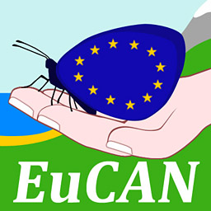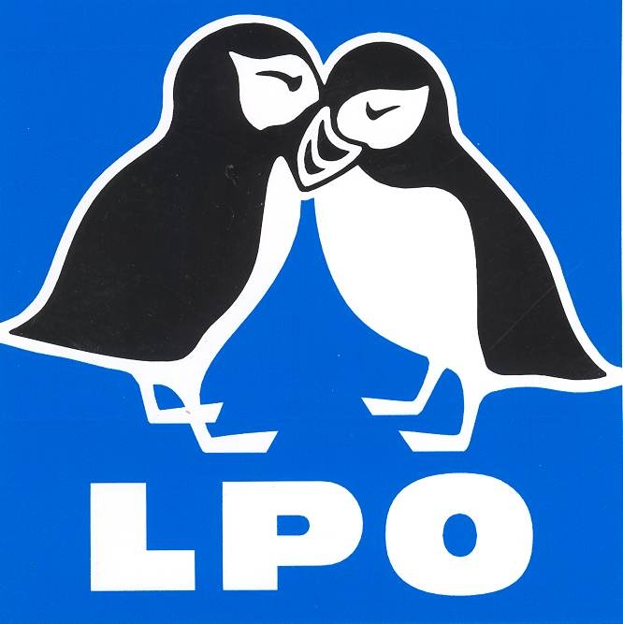

EUROPEAN CONSERVATION ACTION NETWORK
EuCAN Community Interest Company

WILDLIFE HOLIDAYS AND PRACTICAL CONSERVATION VISITS 2017

Expression of interest form

Please indicate which of these opportunities you would be interested in:
Further information with definite prices and confirmed details will be sent out in October. You do not need to make any firm commitment at this stage but we would like to gauge the level of interest in these proposed visits.

Monday 21st – Wednesday 30th November 2016
………..
Practical Conservation visit to La Brenne, central France. There will be a range of different tasks to tackle, lovely food, comfortable accommodation and flocks of cranes totalling 3000+ as an extra attraction! £300 / £150 unwaged/concessions inc travel. For a report on our last working visit see: http://www.eucan.org.uk/europe/practical-conservation-visit-to-la-brenne-february-2015/

Wednesday 26th April – Tuesday May 2nd
………..
Study tour to the Netherlands to see the Oostvaardersplassen Re-wilding project, European Bison and migrating birds. Two nights each way on the Stena line ferry
between Harwich and the Hook of Holland, four nights in chalet or tent accommodation
in Lelystad. Cost around £400 inc travel from Dorset.
http://www.staatsbosbeheer.nl/natuurgebieden/oostvaardersplassen

Tuesday 9th – Thursday 18th May
……….
Wildlife Holiday to Aggtelek National Park, north-eastern Hungary. One of the richest areas of Hungary for wildlife, and May is a superb time to visit for
birds, insects, amphibians and wildflowers. - not to mention the bats, mammals,
scenery, culture, caves and local food! Cost approx. £1200 for the 9 nights full board
and minibus transport in Hungary but excl travel to/from Hungary. For a report on our
last visit there:
http://www.eucan.org.uk/europe/2015-wildlife-holiday-to-aggtelek-national-park-
northern-hungary/

Sunday 28th May – Monday June 5th
………
Wildlife Holiday to Estonia An 8 night holiday with 3 nights in the west of the country to see the fabulous limestone flora and fauna, and the remaining time further
east to explore the peatbogs and forests. Estonia has one sixth of the land area of the
UK but a population of only 1.3 million! To see the photos from the EuCAN 2016
working holiday to this area, please go to:
https://www.flickr.com/photos/20427639@N06/collections .
Cost approx. £1200 for the 8 nights full board and minibus transport in Estonia but excl
travel to/from Estonia.

Late Summer 2017, dates tbc.
……….
Conservation working holiday to Estonia to work with the Estonian Fund for Nature (ELF) to help to reinstate the protected mires and peat bogs damaged by years of
neglect and forestry operations. This work will be fairly arduous and will require a
good level of fitness. Cost tbc but will be subsidised by any profits from the June
Wildlife holiday.

- Your Name ………………………………………………. Mr/Mrs/Ms/……..

- Date of Birth …………………………………………………..

- Postal Address with postcode:

- Email address:

- Contact phone numbers:
  - Daytime:
  - Evenings:
  - Mobile:

Please return completed forms by email as word attachments to nigelspring@yahoo.co.uk. We would prefer email rather than postal applications.

For further information, please visit: www.eucan.org.uk
Contact: Nigel Spring Tel: 01963.23559 Mobile: 07981.776767
Email: nigelspring@yahoo.co.uk.

EuCAN CIC is registered in England and Wales as a Community Interest Company limited by guarantee.
Registered Company no. 7513162. Registered Office: 346, Mundens Lane, Alweston, Sherborne, Dorset DT9 5HU
The aims of EuCAN CIC are

- to encourage and facilitate cultural exchange and the exchange of environmental ideas and skills between the UK and other countries (particularly within the European Union).
- to promote practical conservation volunteering both in the UK and abroad
- to promote the conservation of the physical and natural environment by promoting biodiversity.
- to encourage sustainable development in the rural economy through environmentally sensitive farming and food production.
- to promote the research and development of systems of conservation management and agriculture which are both economically viable and environmentally sustainable.
- to provide education and training related to these activities and to disseminate relevant information and guidance to the public at large.
www.eucan.org.uk

