European Conservation Action Network

EuCAN Community Interest Company

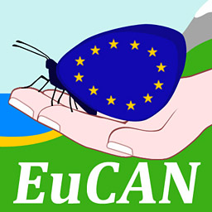

CONSERVATION VISIT TO LA BRENNE, CENTRAL FRANCE

Saturday November 21st – Monday November 30th 2015

Species list (not including birds – see separate list)

22.11.15 Essarts hide: Coypu
23.11.15 La Touche lake: Cep mushroom, Harvest Mouse nests, Coypu diggings
23.11.15 Douadic: 5 Roe Deer
24.11.15 La Touche; Ear Fungus
26.11.15 Essarts: Winter Moth
28.11.15 Le Sous: Wood Crickets, Common Frog
29.11.15 Foucault Hide: 4 Coypus
29.11.15 Purais hide: 4 coypus.
30.11.15 Sées on the way home: Hummingbird Hawk-moth

The aims of EuCAN CIC are
- to encourage and facilitate cultural exchange and the exchange of environmental ideas and skills between the UK and other countries (particularly within the European Union).
- to promote practical conservation volunteering both in the UK and abroad
- to promote the conservation of the physical and natural environment by promoting biodiversity.
- to encourage sustainable development in the rural economy through environmentally sensitive farming and food production.
- to promote the research and development of systems of conservation management and agriculture which are both economically viable and environmentally sustainable.
- to provide education and training related to these activities and to disseminate relevant information and guidance to the public at large.
www.eucan.org.uk

EuCAN CIC is registered in England and Wales as a Community Interest Company limited by guarantee.
Registered Company no. 7513162. Registered Office: 346, Mundens Lane, Alweston, Sherborne, Dorset DT9 5HU.

