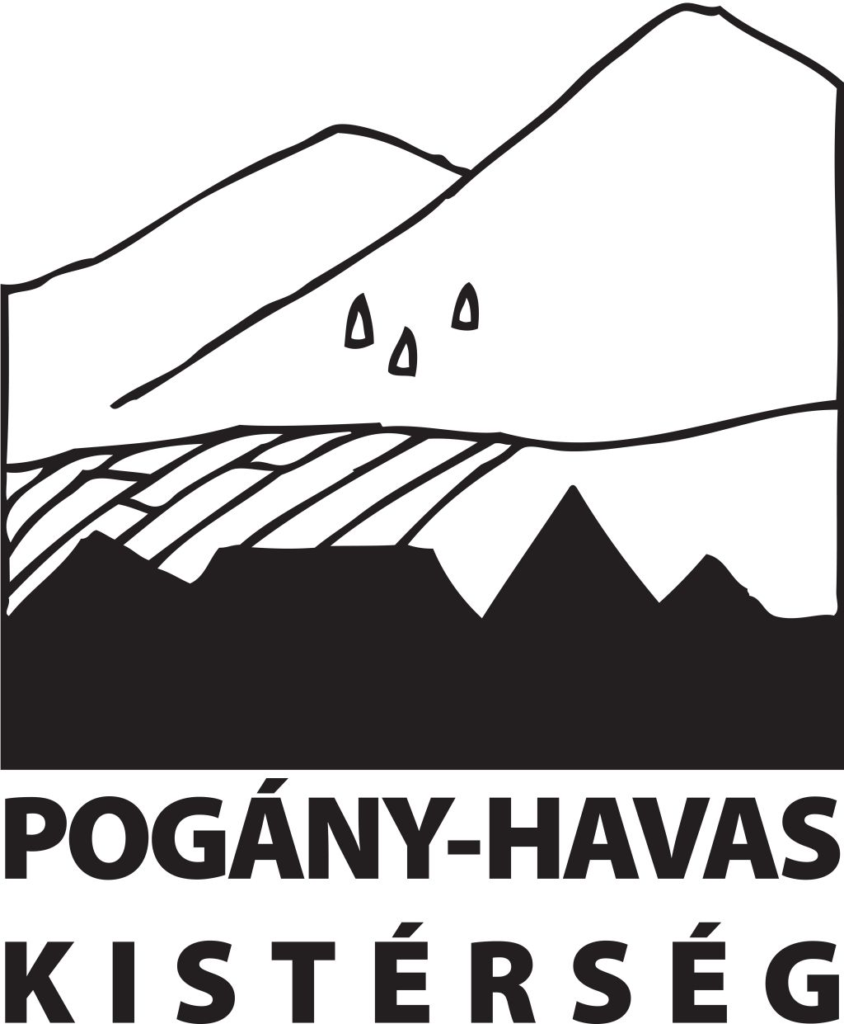

EUROPEAN CONSERVATION ACTION NETWORK - EuCAN CIC

CONSERVATION WORKING HOLIDAY TO TRANSYLVANIA

International Scything Festival and scrub management work
Saturday August 6th – Tuesday August 16th 2016

Joining Instructions and Programme

This is the eighth year of the International Scything and Haymaking Festival run in Gyimes in the eastern part of Transylvania by Attila Sarig and the Pogany-Havas Association in conjunction with the Barbara Knowles fund. Romania, and Transylvania in particular, have the most biodiverse hay meadows in the world as a reflection of the traditional low-input, very small scale agricultural systems that predominate there. Romania has about a quarter of all the farmers in the EU – and their land holdings are on average extremely small, too small in many cases to make them eligible for EU farm subsidies which are handed out generously to large landowners who need them least. Many of the small-scale farmers rely on horses and oxen for transport so hay is of huge importance to them as a fuel.

The meadows where the hay is cut during the summer for use during the long winters are amazingly rich in wildflowers and the insects and other wildlife that rely on them.
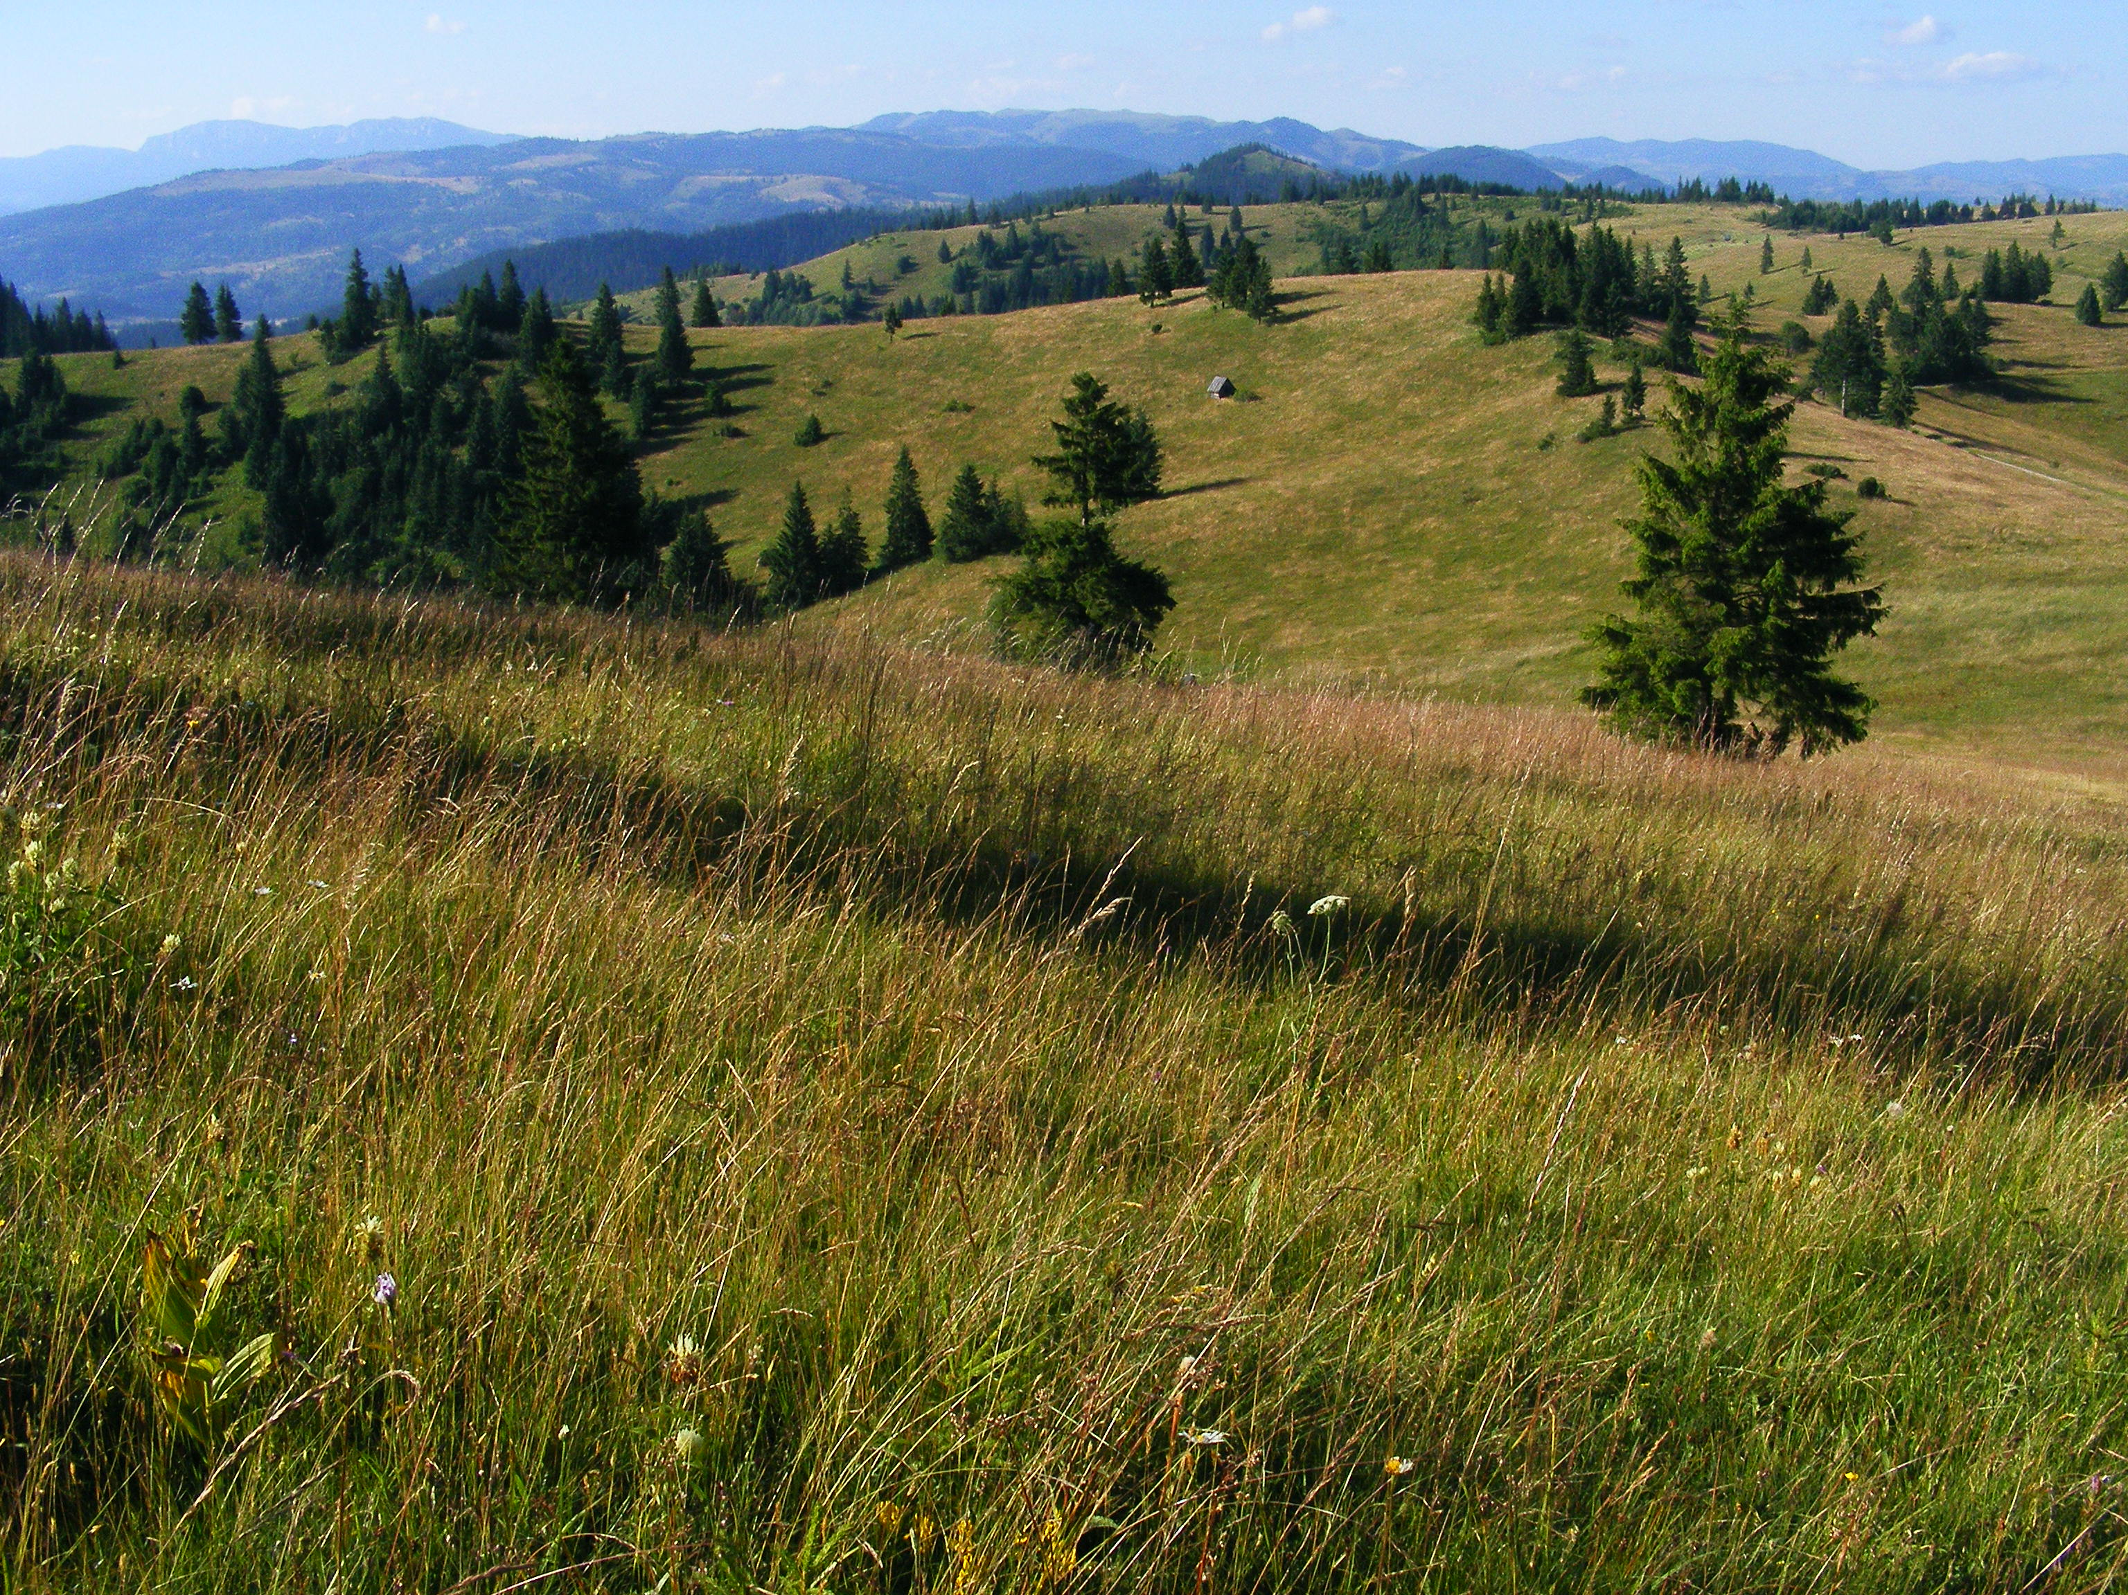

For a variety of reasons, political, demographic or technological, many of these subsistence farmers are giving up or finding it easier to allow their land to revert to forest. The precious hay meadows, once abandoned, rapidly become overgrown with scrub and ultimately forest. Even though the intermediate stages may be particularly high in insect and other species (especially butterflies and moths), in the end the biodiversity is lost and some of the most valuable habitat in Europe disappears.

Programme
We will pick up participants from the train stations at Miercurea Ciuc or Gyimes in the afternoon of Saturday August 6th and drop you back at a convenient time on Tuesday 16th. You will have to make you own travel plans to get there and back and may like to incorporate this working holiday into a longer visit to Romania or elsewhere in eastern Europe. It would certainly be worth it and would dilute the overall cost of travelling out there. Rail travel in Europe is best planned through the ‘Man in seat 61’ website www.seat61.com . There are air travel links from the UK to Bucharest, Targu Mures and Bacau.
During the Haymaking Festival (7th – 14th August) we will join in some of the haymaking and other activities, but also spend time in the higher meadows clearing invasive scrub using handtools and chainsaws so that these once-productive fields can be brought into production next season. Qualified chainsaw operators will be very welcome. Over the whole stay we would hope that each person will do at least 4 days scrub clearance work.

Cost
The cost of the accommodation and all meals will be £30 per day – ie £330 in total. This will include transport to and from the nearby rail stations and local travel, but it will not include your personal insurance or your return ticket from the UK to the pickup point. And it will not include alcoholic drinks. If you are selected for this working holiday you will be asked to transfer a deposit of £100 into the EuCAN bank account, only returnable on cancellation if your place can be filled. Our overheads for this visit are being paid for out of EuCAN funds raised through our contract work and the wildlife holidays we ran in 2014 and 2015.
It is easiest for us if you pay your deposit by BACS. Account Name: EuCAN Community Interest Company;
Sortcode: 08.92.99 , account no. 65472987 with your name as the reference.

Checklist of equipment to bring:
**Passport Make sure that your passport has at least 6 months on it. You will also need a photocopy of your passport or your drivers licence as ID to carry with you everywhere.
**International Health Card This has replaced the E111 certificate and can be obtained free via the internet -do not apply through the private company that makes you pay £10! Passengers in minibuses in the EU have to carry one with them.
**Money: we suggest that you bring some Romanian Lei perhaps £100 worth. There are bank machines fairly nearby. Banks like to be told if you are going abroad so that they know that someone hasn’t stolen your card and fled to Europe, so I would suggest that you let the bank know. You will need to have money to cover the cost of drinks, ice creams etc and souvenirs. We also suggest you store the emergency 24hour number for reporting stolen bank cards in your phone.
**Mobile phone/phone charger/euro. Bring your own plug adaptor for phone and battery charging. N.b. It might be worth checking with your phone company that you have a roaming facility on your phone.
**Notebook and pencil.
**Romanian and Hungarian Phrase books – please bring your own so that you have no excuse for not trying the languages! This is a strongly Hungarian area of Romania so you will hear both languages everywhere. Binoculars – please bring a pair as there will be plenty of opportunities to use them.
Camera (+battery charger), handlens if you have them.
You will need to bring a sleeping bag.
Toilet things – including a towel, night clothes, sun block and sunhat (we may as well be optimistic!).
Wet weather gear – waterproof coat and overtrousers. Spare pair of trousers for working in.
Working boots preferably steel-toe capped. Thick working gloves.
A set of smarter clothes and shoes for going out in the evenings.
Bring a warm jumper as the evenings may well be cold.
A small personal 1st Aid Kit – with plasters and a small roll of micropore tape, waspeeze, mosquito repellent (non DEET), antiseptic wipes, a roll of bandage, a medium wound dressing and two prs of disposable gloves. We will be bringing a full 1st Aid Kit as well. We will bring tick hooks but buy your own too (from the local vet!)
A torch.
Plastic box for packed lunch. We can pick up plastic bottles for drinks after we arrive.

**If you are a chainsaw or brushcutter user, we will need you to use the power tools during the visit.
PPE: we can supply helmets and gloves, but you will need to bring your own steel toe-capped boots (brushcutter and chainsaw users) and protective trousers (chainsaw users).. Please bring copies of your certificates of Proficiency in Brushcutter and/or Chainsaw if you have not already shown them to me. If you would like to do brushcutter training before we go, that may be possible as we run fairly regular courses.

Insurance Third party liability insurance is covered by EuCAN’s insurers but you will need to take out your own travel insurance if you do not have a permanent arrangement. You need to bring your European Health Card in case you need medical treatment in Europe but the Personal Health Insurance should cover that too.

Membership of EuCAN CIC We would like all the people who take part in this visit to have joined the CIC beforehand – ie a one-off payment of a minimum of £10 if you are working or £5 minimum if you are out of work. See: http://www.eucan.org.uk/about-us/cic-membership/

For further information, please visit: www.eucan.org.uk
Contact: Nigel Spring Tel: 01963.23559 Mobile: 07981.776767
Email: nigelspring@yahoo.co.uk.
The aims of EuCAN CIC are
- to encourage and facilitate cultural exchange and the exchange of environmental ideas and skills between the UK and other countries (particularly within the European Union).
- to promote practical conservation volunteering both in the UK and abroad
- to promote the conservation of the physical and natural environment by promoting biodiversity.
- to encourage sustainable development in the rural economy through environmentally sensitive farming and food production.
- to promote the research and development of systems of conservation management and agriculture which are both economically viable and environmentally sustainable.
- to provide education and training related to these activities and to disseminate relevant information and guidance to the public at large.
www.eucan.org.uk

EuCAN CIC is registered in England and Wales as a Community Interest Company limited by guarantee.
Registered Company no. 7513162. Registered Office: 346, Mundens Lane, Alweston, Sherborne, Dorset DT9 5

