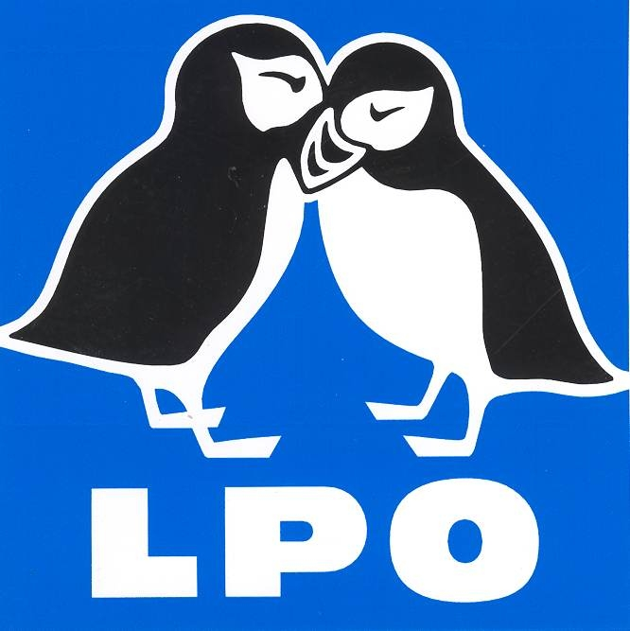

EUROPEAN CONSERVATION ACTION NETWORK
EuCAN CIC

CONSERVATION VISIT TO LA BRENNE, CENTRAL FRANCE

Monday November 21st – Wednesday November 30th 2016

Travel Information and Equipment list

This will be a practical conservation visit to our partners in this beautiful area of France and we will be expecting to work for five of the days we are there. There will be plenty of scope for chainsaw and brushcutter operators with valid tickets to work with us and it will give an opportunity for recently trained operators to get a continuous block of practice. We have visited La Brenne on many occasions in the past and have carried out some very useful work with them while having a great time and enjoying the food, wine, beautiful places and the wildlife. We have always been shown wonderful hospitality during our visits there. Although it will obviously be winter, there will still be plenty to see – the area is renowned for its wildfowl and other wintering birds – and particularly for the flocks of cranes which last year numbered over 4000!

Monday November 21st The minibus will be leaving Alweston (nr Sherborne) at 4.15pm, driving to Portsmouth for the 10.45pm ferry to Caen. We will be stopping at pre-arranged pick-up points on the way (places/times to be arranged as necessary) through Blandford and Wimborne, Ringwood main carpark, onto the M27,Rownhams Services on the M27, Southampton Parkway station (about 6.30pm) and then to the Cams Mill Inn on the edge of Fareham for supper around 7pm. See: http://www.camsmill.co.uk/
We will drive to the ferry terminal after supper for embarkation at about 10pm. There will be cabins for us on the ferry and we will have breakfast before docking at Caen at about 7am (French time – one hour ahead).

Could you please think about where you want to meet us – we will discuss this on the phone/by email.
Bear in mind that on the return trip, we will not get back to Dorset until after well 11pm on the evening of the 30th, as the ferry does not dock until 9.15pm, so you will need to think of a way of getting home pretty late. It should be possible to get to Southampton Parkway for the late London train for those of you hoping to head back towards London that night – please double check the times. There is a cheap Premier Inn next to the station at Southampton Parkway. It may well be possible to leave your vehicle at the Cams Mill Inn (we have done this before without any trouble or cost). Another possibility is to park in the Village Hall carpark in Alweston which I can arrange for you if necessary.

Tuesday November 22nd The drive to La Brenne will take about six hours; we will stop on the way for breakfast/coffee and a village market and further along to buy food for a picnic somewhere.

We are staying in a gîte in the centre of Mézières-en-Brenne, in two twin rooms, two 4-bedded rooms and two 6-bed rooms. There is an option for single rooms and rooms with en-suite facilities but there will be a supplement for that. We will be meeting Tony Williams, the conservation officer in La Brenne for the LPO (BirdLife International partner in France), in the early evening for an introductory talk before going out to supper nearby. In the evenings we will make our own suppers as a group in the gîte but we will also be eating out on two nights (more if the budget can stretch to that). We will buy bread and croissants from the bakery each morning for breakfast and do the shopping from the village store and/or the market on the Thursday to make our picnic lunches.
Wednesday November 30th We will leave the area as soon as possible after an early breakfast and drive back to Caen to catch the ferry at 4.30pm getting into Portsmouth at 9.15pm. We shall have supper on the ferry. We hope to get back to Alweston before midnight, so arrange your drop-off points accordingly.

Meals during the journey, bar tabs and travel costs to and from the meeting point are not included in the cost of this visit so you need to bring your own funds to pay for these.

Equipment List
There are washing and drying facilities in the gîte, so it should not be necessary to bring 7 of each piece of clothing! I suggest that you bring one medium sized case/bag (if there is a choice between a giant case and two smaller ones, bring the two smaller ones!).
Your passport, International Health Card, money, camera etc should be in a small haversack to carry separately from the rest of your luggage. You will also be able to use this bag during the stay to carry packed lunches, binoculars, water bottle, id books, etc.
Please photocopy your passport (in black and white – it is illegal to make a colour copy of a passport apparently) and keep the copy in your main bag – that will make it much easier if anything happens to the original!

Just in case anything goes astray, I would recommend that you label each case/bag with your name, mobile phone number (beginning 0044..) and home address on it. Please ensure that your passport and your wallet are in the small bag as the large one may be buried in the trailer.

**Identification Books. It is useful to have a library of id books (in English) which covers as wide a range of animal and plant groups as possible. We shall transport these in the minibus. To avoid duplication and to minimise the weight, I have listed below the books we are taking in the minibus, although some of these may be redundant at this time of year!

We have the Collins Guides to Alpine Flowers, Mediterranean Flowers and the Wildflowers of Northwest Europe, as well as several other floras; Collins Tree Guide, Bird Guide and new Fungi Guide, Reptiles and Amphibians, Spiders; Butterflies of Europe by Tolman & Lewington and the ‘Collins Guide’ edition of this one; Butterflies of Europe by Tristan Lafranchis; Chinery’s Butterflies and Dayflying Moths of Britain and Europe, and Dragonflies by Dijkstra and Lewington; the Field Guide to the Moths of Britain and Ireland (of limited use as there are 10,000 moth species in Europe and ‘only’ 2500 in the UK!) and the new Micromoth id book, the French European moths (Papillons nocturnes) book and the Chris Manley photo guide to ‘British Moths and Butterflies’; guides to European Grasshoppers and Bushcrickets and to European Bats; and last but not least the two best Field Guide to insects you can get for the UK and Europe, Michael Chinery’s ‘Insects of Britain and Western Europe’ and the more recent ‘A comprehensive guide to Insects of Britain and Ireland’ by Paul Brock. All these books will be transported in the trailer with the moth trap, generator etc. I also have cd’s of the birdsongs of Europe (and bats and amphibians!) though I am not sure they will be needed in late November!
Let me know what else you might have that you could bring. If you have a bat detector, please bring it.

Checklist of equipment to bring:

**Passport (Make sure that your passport has at least 6 months on it and keep it with you, not buried in your main suitcase!)
**International Health Card (this has replaced the E111 certificate and can be obtained free via the internet -do not apply through the private company that makes you pay £10! Passengers in minibuses in the EU have to carry one with them).
**Money: we suggest that you bring some Euros (say 50-100€) It is possible to use bank cards to obtain cash in Mézières-en-Brenne, but bring more cash if you are not planning to bring a bankcard. Banks like to be told if you are going abroad so that they know that someone hasn’t stolen your card and fled to Europe, so I would suggest that you let the bank know. You will need to have money to cover the cost of drinks, ice creams etc and souvenirs. We also suggest you store the emergency 24hour number for reporting stolen bank cards in your phone.
**Mobile phone/phone charger/euro. Bring your own plug adaptor for phone and battery charging. N.b. It might be worth checking with your phone company that you have a roaming facility on your phone.
**Notebook and pencil.
**French Phrase book – please bring your own so that you have no excuse for not trying the language! Binoculars – please bring a pair as there will be plenty of opportunities to use them.
Camera (+battery charger), handlens and telescope, if you have them.
You will not need to bring bedding or sleeping bags.
Toilet things – including a towel, night clothes, sun block and sunhat (we may as well be optimistic!).
Wet weather gear – waterproof coat and overtrousers. Spare pair of trousers for working in.
Working boots preferably steel-toe capped. You will need wellies for working in wet places, please write your initials inside each boot and bring them in a strong plastic bag!
Thick working gloves and a pair of industrial waterproof gloves.
A set of smarter clothes and shoes for going out in the evenings.
Bring a warm jumper as the evenings may well be cold.
A small personal 1st Aid Kit – with plasters and a small roll of micropore tape, waspeeze, mosquito repellent, antiseptic wipes, a roll of bandage, a medium wound dressing and two prs of disposable gloves. We will be bringing a full 1st Aid Kit as well. We will bring tick hooks but you might like to buy your own (from the local vet!)
A torch.
Plastic box for packed lunch. We can pick up plastic bottles for drinks after we arrive.

**If you are a chainsaw or brushcutter user, we will need you to use the power tools during the visit.
PPE: we can supply helmets and gloves, but you will need to bring your own steel toe-capped boots (brushcutter and chainsaw users) and protective trousers (chainsaw users). If you are a chainsaw user, please let me know if you can bring your own chainsaw. We will be providing brushcutters. Please bring copies of your certificates of Proficiency in Brushcutter and/or Chainsaw if you have not already shown them to me. If you would like to do brushcutter training before we go, that may be possible as we run fairly regular courses.

Insurance Third party liability insurance is covered by EuCAN’s insurers but you will need to take out your own travel insurance if you do not have a permanent arrangement. You need to bring your European Health Card in case you need medical treatment in Europe but the Personal Health Insurance should cover that too.

The Programme for the visit
On our first day in La Brenne we will explore the area to see the landscape and wildlife and some of the local towns and villages. We will work on five of the remaining days and have the second Sunday off for cultural tours and free time for walking cycling, birdwatching etc. There are bicycles available for us to use during our time off, and plenty of tracks and lanes to explore. The work will involve cutting and burning willow, blackthorn and other scrub on important areas of grassland and marsh. At this time of year, it may well be cold but we will have fires to warm us up!

Useful telephone numbers: Tony Williams Chérine reserve 0033.254.28.11.04 mob: 0033.675.136497
Nigel and Kathy at home 01963.23559. Nigel’s mobile: 07981.776767.

Registration form I will be sending out an enrolment form for you to complete before the visit, so that we have all the necessary dietary and medical info.

What are we likely to see during our stay?
To get an idea of what we might see during our stay, look at the Visits section of our website www.eucan.org.uk . One of the most exciting attractions of La Brenne in winter is the huge number of overwintering cranes that gather there – last year’s flocks exceeding 4000, and in 2014 the numbers reached a staggering 34,000 at one point!

Payment We have started running wildlife holidays to raise money for our company; the profit made on the holidays to La Brenne and Hungary in 2014 and 2015, and the proceeds of the contract work we do through the year, will enable us to subsidise this practical conservation visit. We are also being helped by a generous contribution from the Chérine reserve. We would like all the people who take part in this visit to have joined the CIC beforehand – ie minimum of £10 if you are working or £5 minimum if you are out of work. See: http://www.eucan.org.uk/about-us/cic-membership/ This Brenne visit costs a minimum of £150 if you are out of work, or £300 minimum if you are employed or retired. It is easiest for us if you make all your payments by BACS. Account Name: EuCAN Community Interest Company;
Sortcode: 08.92.99 , account no. 65472987 .
We are very much looking forward to meeting you and to spending another week in La Brenne.

Nigel Spring and Kathy Henderson

EuCAN CIC is registered in England and Wales as a Community Interest Company limited by guarantee.
Registered Company no. 7513162. Registered Office: 346, Mundens Lane, Alweston, Sherborne, Dorset DT9 5HU.

