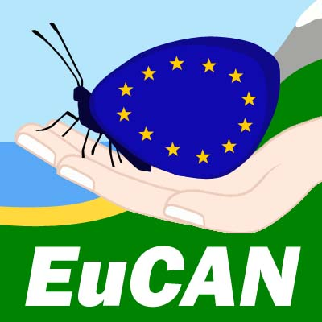

**EUROPEAN CONSERVATION ACTION NETWORK - EuCAN CIC**

**Residential summer weekend at Knepp July 2nd – 4th 2016**

**Participant Registration Form**

# Please complete one form per person

*The information will be held in confidence in accordance with the Data Protection Act, and referenced by the leader(s) in case of an emergency whilst on the placement.*

*We may use your personal details in order to contact you.*

**Your Details**

Title ………. Surname …………………………………………………. Gender…………….

Forename……………………………………… Date of Birth…………………

Address ……………………………………………………………………………….

…………………………………………………………………………………… Postcode…………..

Telephone contact numbers Daytime…………………………….

Evenings…………………………….

Mobile………………………………

Email Address………………………………………………………..

Present Occupation…………………………………………National Insurance No. …………………

**Emergency Contact *you must give the details of someone we can contact in case of an emergency***

## Name……………………………………… Telephone no. ……………………………

Emergency Contact email address: ……………………………………………………………..

Relationship to you……………………………………………

GP practice / Tel contact: ………………………………………………………………………..

***Participants will receive contact details for other members of the group so that you can travel together if you want. We strongly encourage you to agree to your details being included on this list, but if you do not wish to do so,* please indicate this here*…………………………***

***We would like to be able use the photos from our visits for publicity purposes, website etc.* Please indicate here if you do not want photos that include you or that were taken by you to be used in this way …………………….**

**Diet**

Have you any special dietary needs?

Are you a vegetarian? ...............

If you are, please indicate whether you eat Fish……………………………

Cheese………………………….

Eggs……………………………

Health and Fitness considerations

Please note any mental or physical difficulties and any activities these may prevent you from doing.

……………………………………………………………………………………………………………….

To ensure First Aiders are aware of relevant information, please inform us of any medication you are taking

………………………………………………………………………………………………………………..

**Money**

**If you are unable to take up your place and it cannot be filled by someone else, you will forfeit the financial contribution you have made.**

**Declaration Please sign below**

1. I have read the briefing and have evaluated my suitability/ability for this visit.
2. I am not undergoing any medical treatment that might affect me on this weekend.
3. I will bring all my appropriate medication and will inform the organisers of any changes in my medication between now and the beginning of the placement.
4. During the visit, I will notify the leaders of any medical problems and/or symptoms as they occur.
5. I agree to follow EuCAN policies and procedures when engaged in their projects and activities.
6. I understand that any anti-social behaviour that threatens the well-being of the group will result in dismissal from the placement with the loss of any money paid.
7. I have read and understood the Risk Analysis for the visit – on the EuCAN website.
8. I declare that all the information given by me on this application form is correct.
9. I consent to my personal details being used for the purposes described, and shall advise EuCAN of any changes to my circumstances.

**Signed ……………………………………………… Print ………………………………….**

Date…………………………………………………

Could you complete this registration form and return it by email to [*nigelspring@yahoo.co.uk*](mailto:nigelspring@yhaoo.co.uk) and also post a signed copy of it to

Nigel Spring, 346, Munden’s Lane, Alweston, Sherborne, Dorset DT9 5HU.

Cost of the weekend: the fee for this residential weekend is £60 (£50 if you are unwaged). This includes the 2 nights camping, the supper on the first evening and the breakfasts and lunches on the Sunday and Monday. The tour of the Re-wilding Project on the Sunday morning is free but only 13 can take part; priority will be given to those who did not take part in 2015.

It is easiest for us if you make all your payments by BACS. Account Name: EuCAN Community Interest Company; Sortcode: 08.92.99 , account no. 65472987. Please put your name and Knepp on the reference line.

**Membership of the CIC**: we would like all the people who are selected for this visit to have joined the CIC beforehand – ie minimum of £10 if you are working or £5 minimum if you are out of work.

See: <http://www.eucan.org.uk/about-us/cic-membership/> This is a one-off payment.